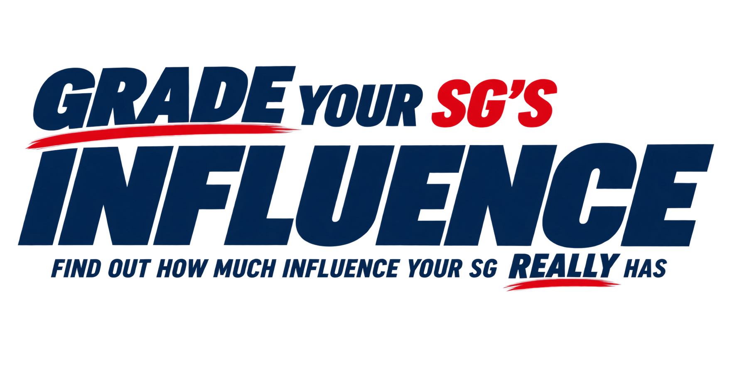QUICK INFLUENCE CHECK
How Much Influence Does Your SG Really Have?
This quick check gives you a snapshot of your Student Government's influence across seven key areas.
For each question, answer YES, SOMEWHAT, or NO.
1. AUTHORITY
Does your SG have formal authority to make decisions—not simply provide input or recommendations?
☐ YES
☐ SOMEWHAT
☐ NO
2. STUDENT FEES
Does your SG have authority over student fees or other significant student-funded resources?
☐ YES
☐ SOMEWHAT
☐ NO

3. GOVERNANCE
Does your SG have a meaningful role in institutional governance, committees, boards, or other decision-making bodies?
☐ YES
☐ SOMEWHAT
☐ NO
4. STUDENT ORGANIZATIONS
Does your SG have authority to fund, recognize, oversee, or otherwise make decisions affecting student organizations?
☐ YES
☐ SOMEWHAT
☐ NO
5. REPRESENTATION
Is your SG formally recognized as a representative or official voice of the student body?
☐ YES
☐ SOMEWHAT
☐ NO
6. STUDENT PARTICIPATION
Do students participate meaningfully in SG elections, programs, initiatives, meetings, and other opportunities to engage with their government?
☐ YES
☐ SOMEWHAT
☐ NO
7. IMPACT
Does your SG actually change decisions, policies, programs, or conditions for students?
☐ YES
☐ SOMEWHAT
☐ NO
YOUR QUICK INFLUENCE SNAPSHOT
Count Your Answers
YES: __________ SOMEWHAT: __________ NO: __________
WHAT DOES YOUR SNAPSHOT TELL YOU?
Mostly YES
Your SG appears to have a strong foundation for influence. You have authority, opportunities to participate in institutional decision-making, and evidence that your SG is connected to students and producing results.
A Mix of YES and SOMEWHAT
Your SG has areas of influence, but there may be opportunities to use its authority more effectively or strengthen its connection to students and institutional decision-making.
Mostly SOMEWHAT or NO
Your SG may have less influence than you assume or may not be using the authority it already has. The first step is to find out exactly what your SG is authorized to do and where its influence can be strengthened.
WANT THE FULL PICTURE?
The Enhanced 54-Point Assessment takes a much deeper look at these seven areas of SG influence.
It can help you identify where your SG is influential, where it has untapped authority, and where it has opportunities to become more effective.
TAKE THE ENHANCED 54-POINT ASSESSMENT →
https://www.asgaonline.com/main/grade-your-influence
ASGA — www.asgahome.com

